Table of Contents
1. Introduction 1
1.1 Project Overview 2
1.2 Objectives 2
2. Problem Solution 2
3. Features 2
3.1. Core Functionality (Console & GUI) 3
3.2. GUI-Specific Features 3
4. OOP Concepts Implemented 4
4.1 Inheritance 4
4.2 Polymorphism 4
4.3. Encapsulation 4
4.4. Abstraction 4
4.5. Static Members 4
5. Code 4
5.1. Base Classes: 5
5.2. Derived Classes 6
6. Code + Output: 9
6.1. Day Simulation: 9
6.2. Market Transactions: 10
7.1 Dashboard 12
7.2 Market Panel: 14
8. Automation Difference Between Console & GUI Versions 14
8.1 Command Line Interface: 15
8.2 Graphical User Interface: 15
Conclusion 16
Key Achievements: 16
1. OOP + GUI Integration: 16
2. Educational Value: 16
3. User-Centric Design: 16

1. Introduction

1.1 Project Overview
This project simulates a digital farm management system where users can:
- Manage livestock (cows and chickens) with health and feeding mechanics.
- Cultivate crops (wheat and corn) with growth cycles and harvest yields.
- Assign workers (animal caretakers and field workers) to automate tasks.
- Engage in a dynamic market to buy/sell farm products.

1.2 Objectives
The objective of this project was to develop a Digital Farm Management System using C++ with both a console-based interface and a Graphical User Interface (GUI). The system simulates farm operations, including livestock management, crop cultivation, worker assignments, and market transactions. The GUI enhances user interaction by providing a visual and intuitive way to manage the farm, making the system more accessible and engaging.
- Demonstrate object-oriented programming (OOP) principles in Python.
- Build an interactive Streamlit GUI for user-friendly farm management.
- Simulate real-world farm economics (supply/demand, health decay).

2. Problem Solution
Managing a farm involves tracking multiple tasks, such as feeding animals, monitoring crop growth, and handling finances. A text-based system works functionally but lacks user-friendliness.
This project solves these challenges by:
- Providing two interfaces:
  - Console-based for functionality and debugging.
  - GUI-based for better visualization and ease of use.
- Automating farm operations (animal health, crop cycles, market trading).
- Using OOP principles to ensure modularity and scalability.
The GUI improves accessibility, making the system suitable for users who prefer visual interaction over command-line inputs.

3. Features

3.1. Core Functionality (Console & GUI)
- Animal Management
  - Add/remove cows and chickens.
  - Feed animals and check health status.
  - Collect milk and eggs.
  - Simulate health degradation if animals are not fed.

- Crop Management
  - Plant and harvest wheat/corn.
  - Water crops to ensure healthy growth.
  - Track growth cycles before harvest.

- Worker System
  - Assign caretakers for animals and field workers for crops.
  - Manage and perform tasks for animals and crops

- Market System
  - Buy and sell farm products (milk, eggs, wheat, corn).
  - Dynamic pricing and stock availability.
  - Track balance and inventory.

- Day Simulation
  - Progress time to trigger new growth cycles and animal health updates.

3.2. GUI-Specific Features
- Visual Dashboard
  - Real-time updates on animal health, crop status, and inventory.
- Interactive Buttons & Menus
  - Simplified navigation (no manual command typing).
- Graphical Representations
  - Progress bars for crop growth, animal health.
  - Icons for animals, crops, and resources.

- Notifications
  - Alerts for low health, unwatered crops, or harvest readiness.

4. OOP Concepts Implemented
4.1 Inheritance
The Animal and Crop base classes provide shared attributes, while Cow, Chicken, Wheat, and Corn implement specialized behaviors. This eliminates code duplication when adding new farm entities.
4.2 Polymorphism
The feed() and produce() methods behave differently per animal type. Calling these on generic Animal objects automatically selects the correct implementation, enabling flexible farm operations.
4.3. Encapsulation
Critical data like health and milk_capacity are managed through controlled methods. Static variables track inventory securely, preventing direct external access that could corrupt game state.
4.4. Abstraction
Abstract methods like grow() enforce implementation rules while hiding complex logic. Users interact with simple commands ("feed", "harvest") without needing backend knowledge.
4.5. Static Members
Cow.milk_capacity and Chicken.totalEggs provide global inventory tracking. These persist across all instances and sync automatically with the Streamlit UI.
Concept Synergy
Polymorphism enables the WorkerManager to handle animals generically, while encapsulation protects data during GUI interactions. Static variables maintain real-time inventory updates across the system.

5. Code

5.1. Base Classes:
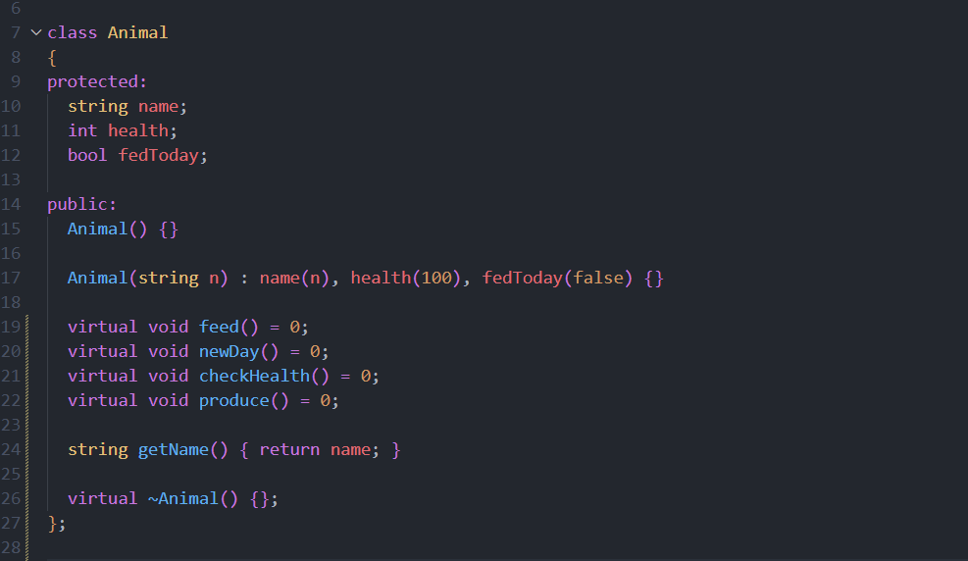

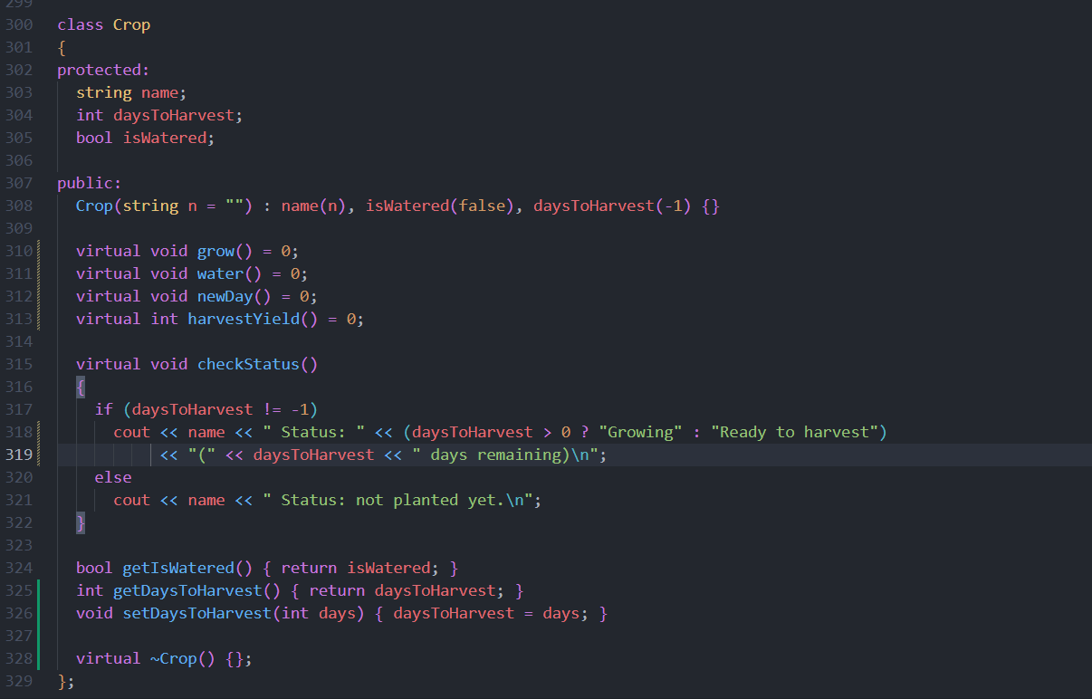

5.2. Derived Classes
First we’ll start with overridden methods of derived classes
Below is the code of Cow child class
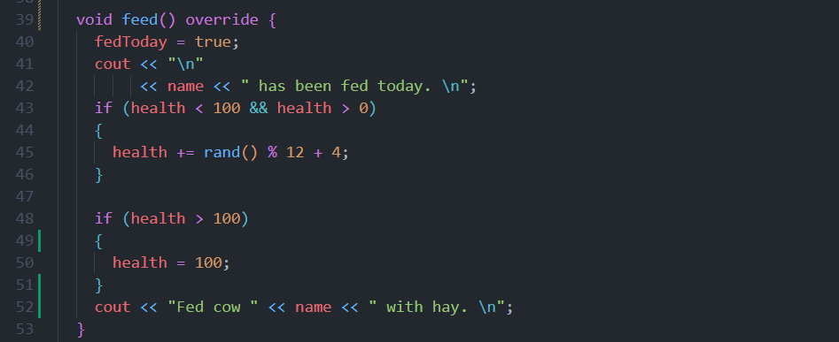

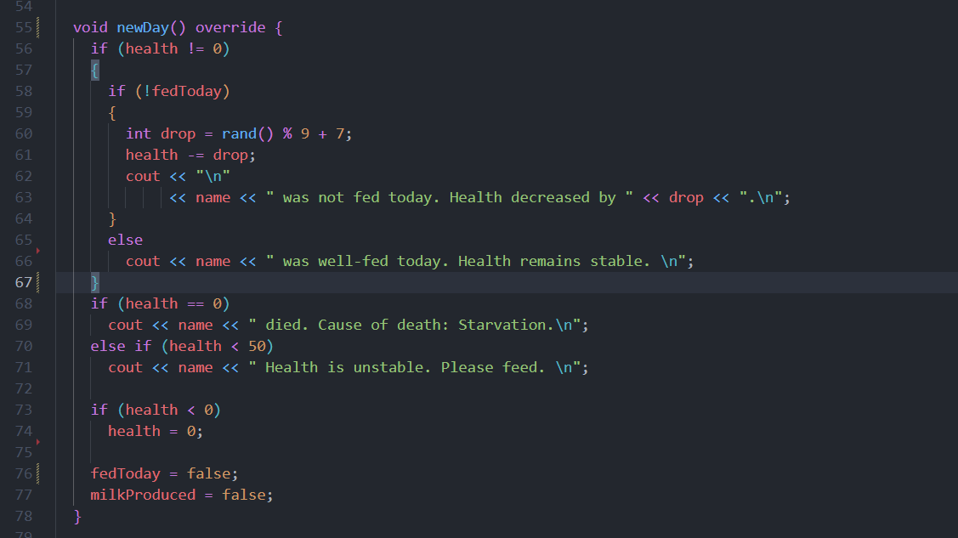

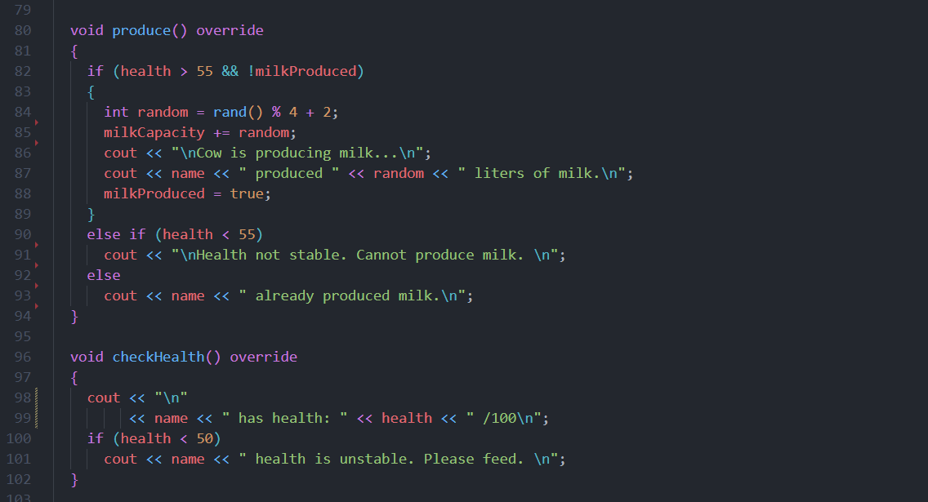

Similarly now the code for the crop derive class
Below is the code of Wheat child class overridden methods

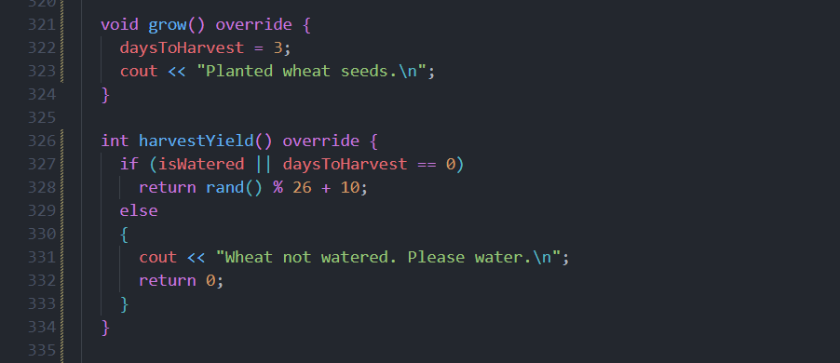

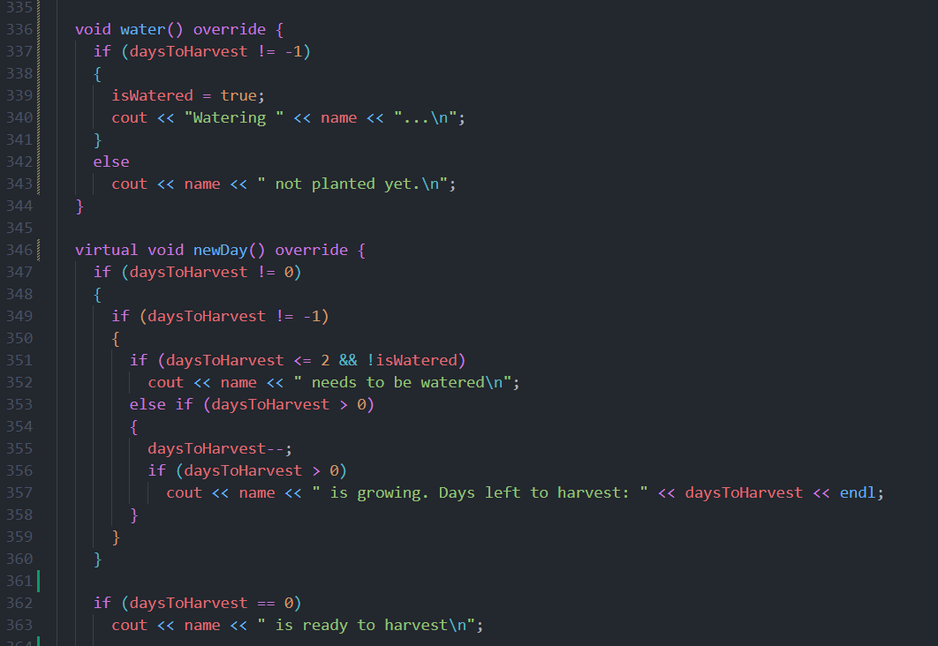

Variables (including static too) and objects

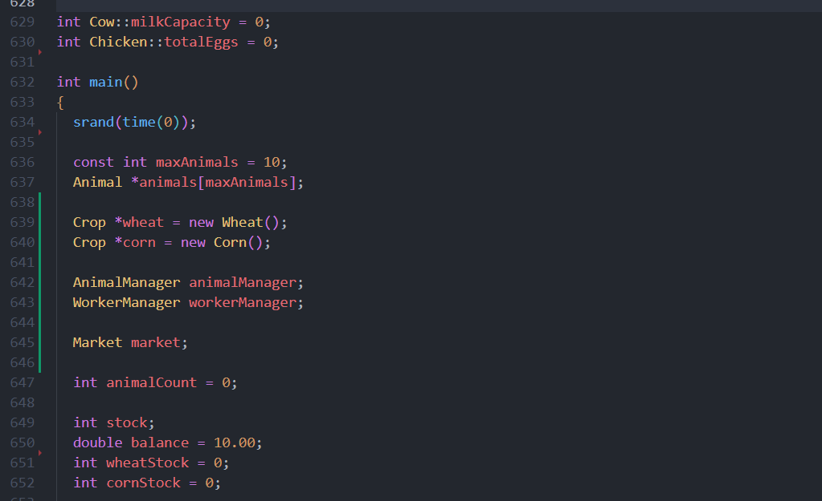

6. Code + Output:

6.1. Day Simulation:

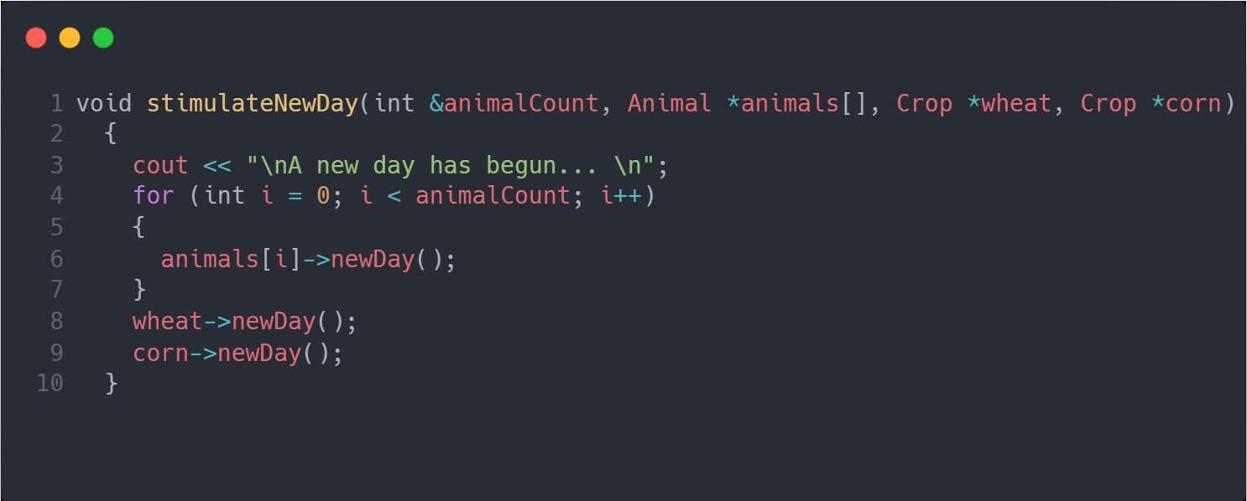

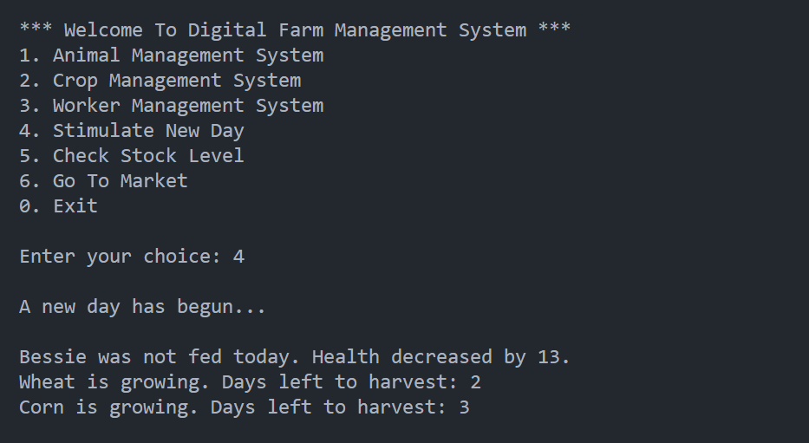

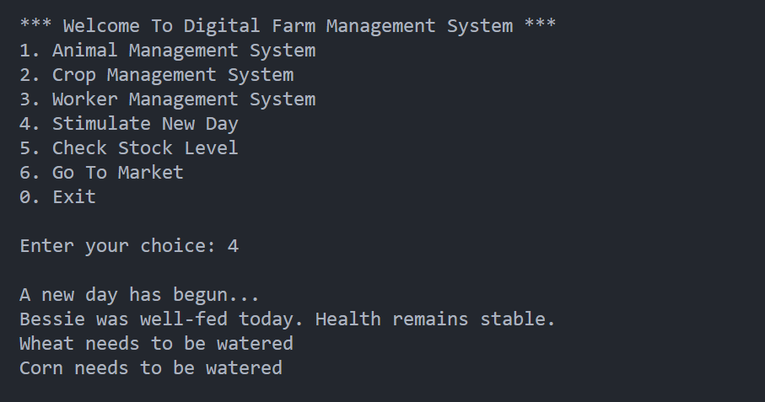

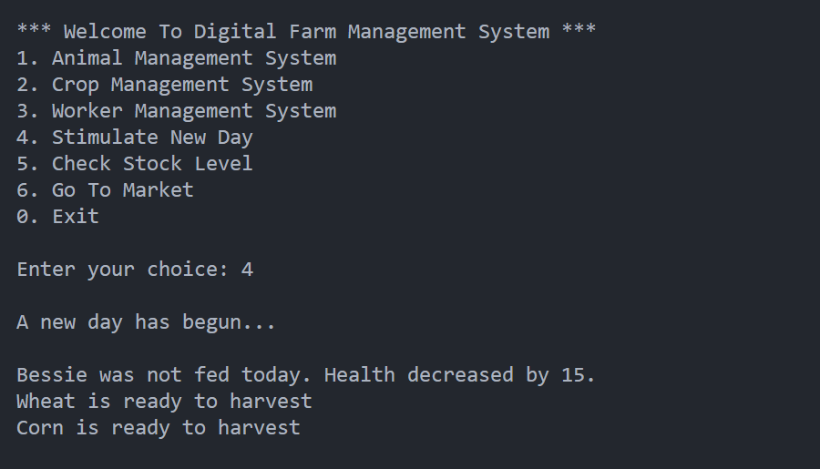

6.2. Market Transactions:
Buying goods
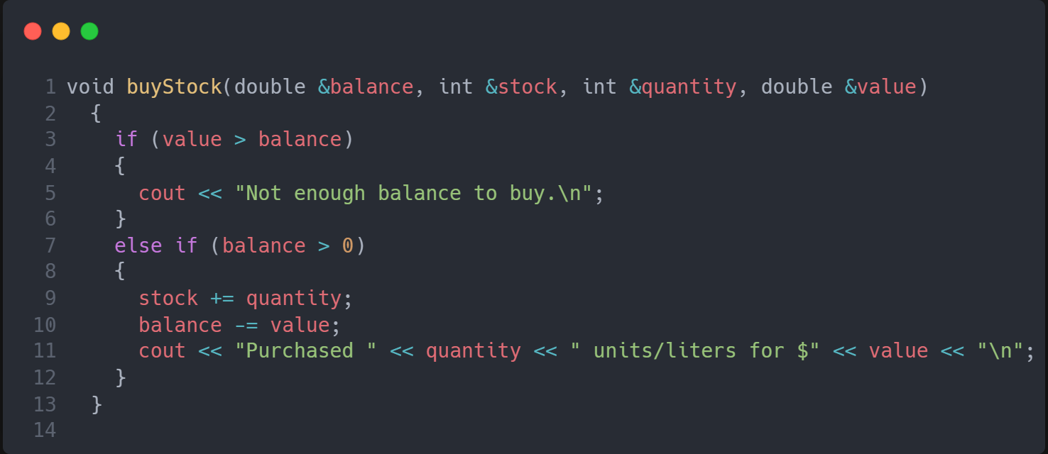
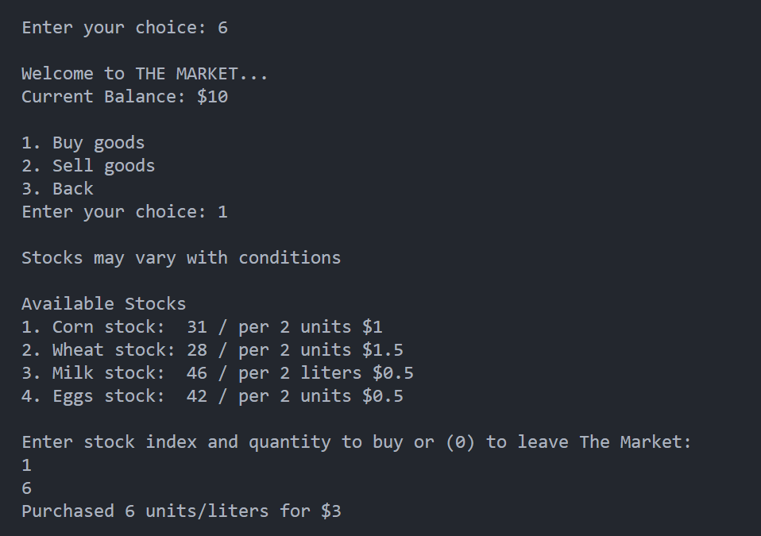

Selling goods
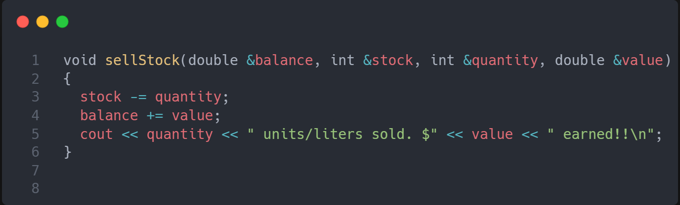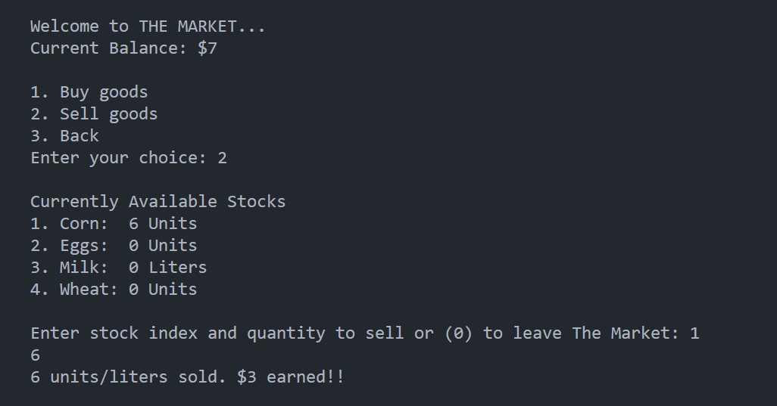

7. Streamlit UI
After building the basic console version of my Digital Farm Management System, I decided to improve the user experience by adding a Graphical User Interface (GUI) using the Streamlit software in C++. The purpose of this was to make the system more interactive, beginner-friendly, and closer to how real applications work visually.

In the GUI version, actions like feeding animals, planting crops, and checking balances are done through buttons, message boxes, and input fields, instead of typing commands in the console. This makes the simulation easier to use and more engaging, especially for users who may not be comfortable with text-based interfaces.

Even though the backend logic of the farm was originally written in C++, using Streamlit helped me present the same concepts in a cleaner, more user-friendly way. This experience taught me how frontend and backend systems can work together, and how Python can be used to quickly build interfaces on top of existing logic.

7.1 Dashboard
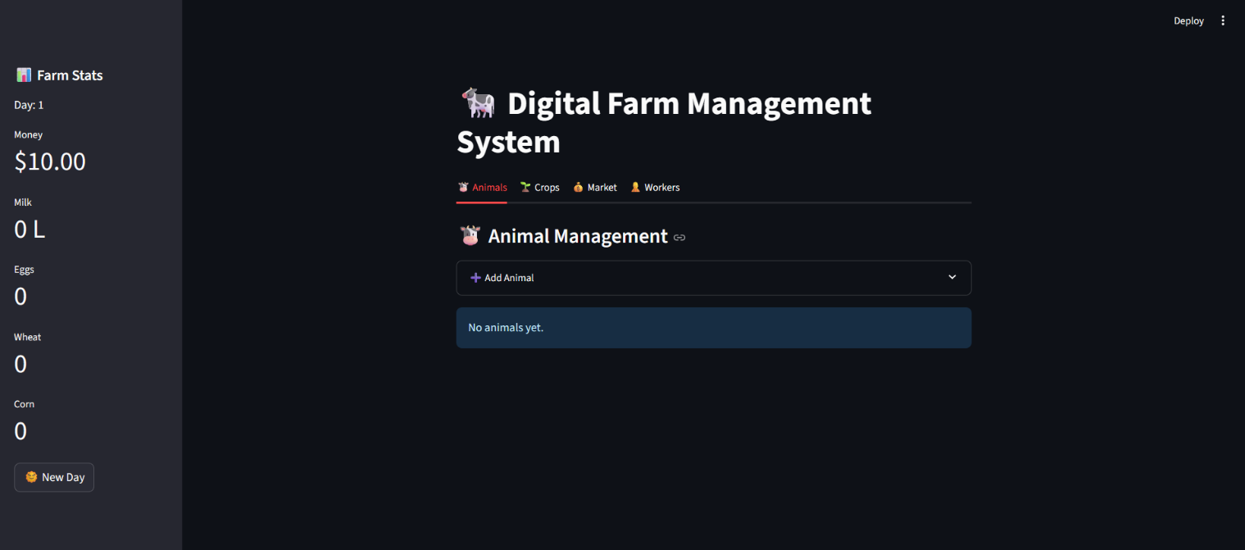

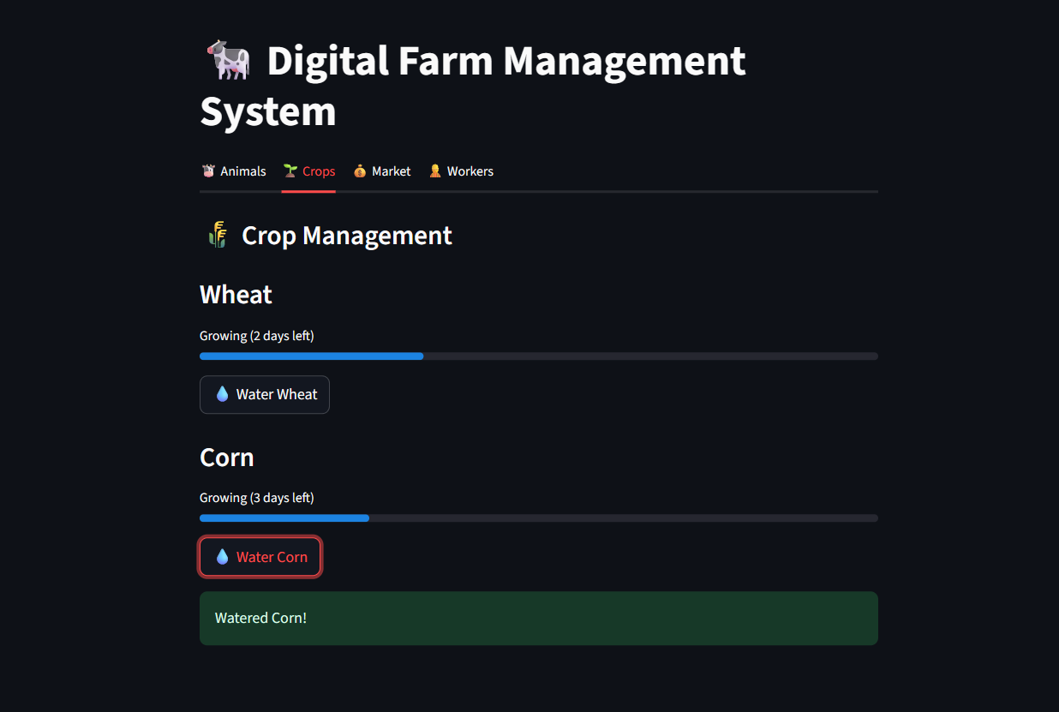

Simulation stats after some days
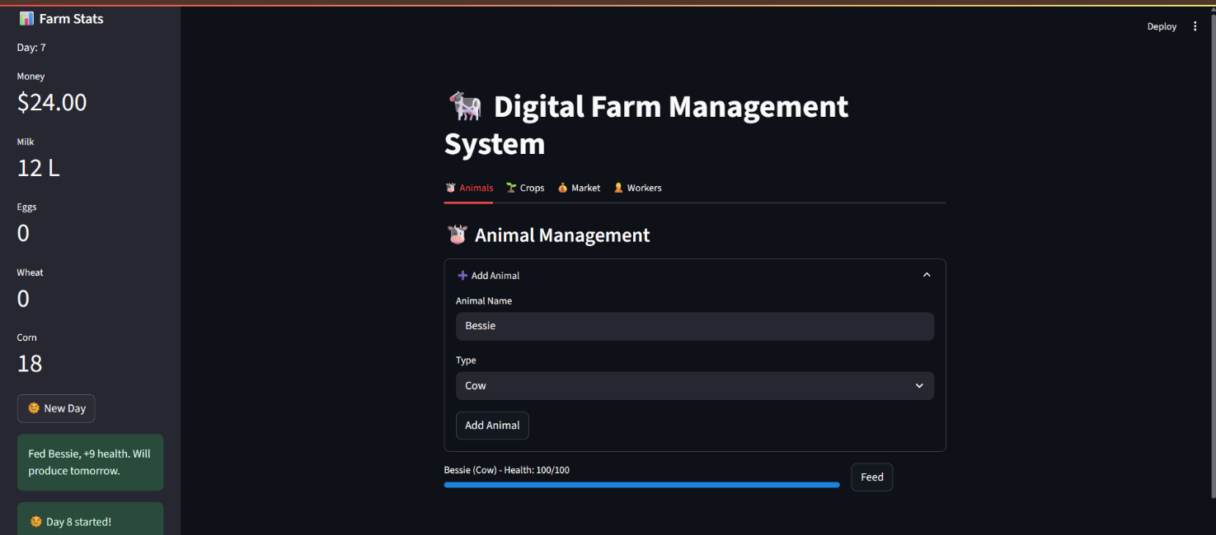

7.2 Market Panel:
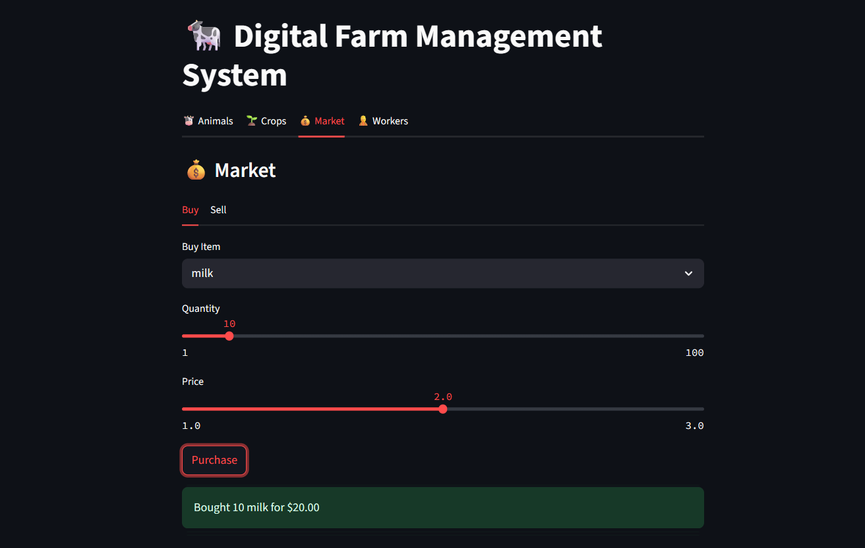

8. Automation Difference Between Console & GUI Versions
In the C++ console version, all tasks like feeding animals, watering crops, and harvesting are done manually by the user. This was done to focus on implementing core logic using basic programming and object-oriented principles.
In the Streamlit GUI version, I introduced optional automation using checkboxes for worker roles:
- Auto Feed Animals
- Auto Water Crops
- Auto Harvest Crops
This simulates real-world farm automation, making the simulation more realistic and user-friendly. It also shows how the same logic can evolve with better user interfaces.

8.1 Command Line Interface:
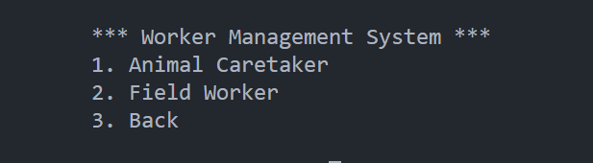
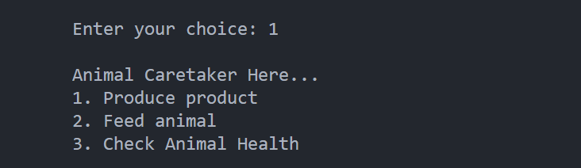
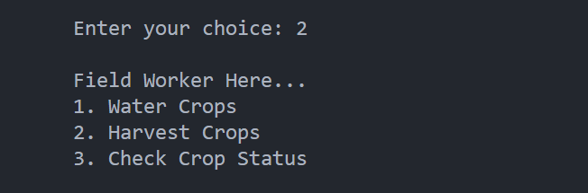

8.2 Graphical User Interface:

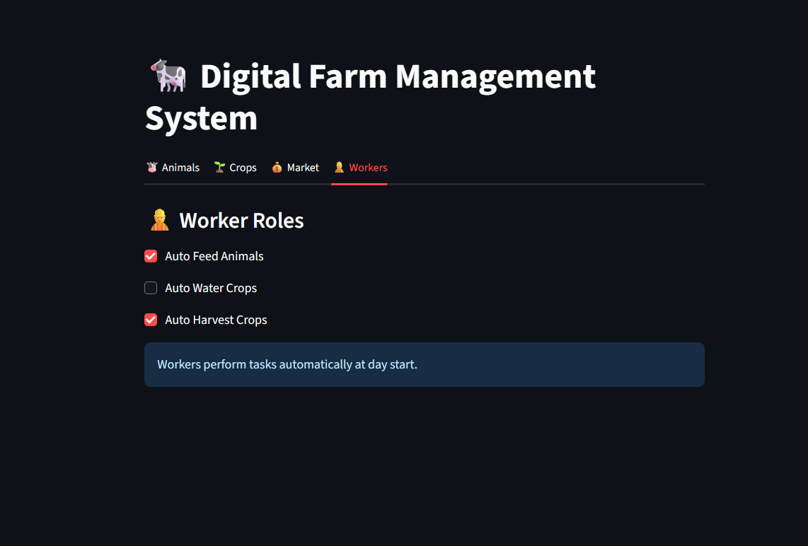

Conclusion
The Digital Farm Management System effectively demonstrates the synergy between object-oriented programming (OOP) and interactive GUI design through Streamlit. By leveraging OOP principles—inheritance, polymorphism, encapsulation, and abstraction—the project achieves a modular architecture that mirrors real-world farm operations.

Key Achievements:

1. OOP + GUI Integration:
Streamlit’s reactive components (buttons, progress bars) seamlessly interact with backend OOP logic (e.g., clicking "Feed Cow" triggers Cow.feed() and updates health bars in real time).
Session state (st.session_state) preserves object states across user interactions, bridging OOP and frontend dynamics.

2. Educational Value:
Serves as a practical example of OOP scalability—new animals/crops can be added by extending base classes without modifying core logic.
Demonstrates event-driven GUI design (e.g., market transactions triggering inventory updates).

3. User-Centric Design:
The GUI simplifies complex operations (e.g., health tracking via visual bars vs. console logs).
Mobile-responsive layout ensures accessibility across devices.
The CLI provided efficient debugging during development, while the Streamlit GUI enhanced accessibility for end-users. Future work could unify both interfaces under a single architecture."

